SYNCHRONIZED

import java.util.*;

import java.lang.*;

import java.io.*;

class table

{

synchronized void printable(int n)

{

try

{

System.out.println("Printing The Table");

for(int i=0;i<=15;i++)

{

System.out.println(n+"x"+i+"="+n*i);

Thread.sleep(2000);

}

}catch(InterruptedException e){

System.out.println("Interrupted Program");

}

System.out.println();

}

}

class newthread implements Runnable

{

int n;

table target;

Thread t;

newthread(table targ,int num)

{

target=targ;

n=num;

t=new Thread(this,"TABLE");

}

public void run()

{

target.printable(n);

}

}

class tab

{

public static void main(String[] args)

{

int num1,num2;

Scanner sc=new Scanner(System.in);

System.out.println("Enter the First Number ");

num1=sc.nextInt();

System.out.println("Enter the Second Number");

num2=sc.nextInt();

table tl=new table();

newthread ob1=new newthread(tl,num1);

newthread ob2=new newthread(tl,num2);

ob1.t.start();

ob2.t.start();

try

{

ob1.t.join();

ob2.t.join();

}catch(InterruptedException e){

System.out.println("Exception Caught");

}

}

}

OUTPUT:

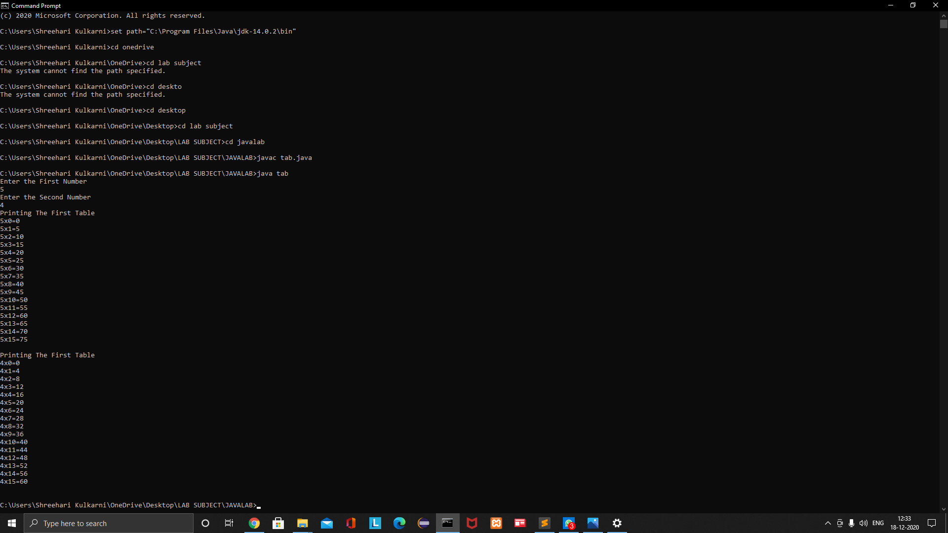

INTERTHREAD

import java.util.*;

import java.io.*;

import java.lang.*;

class car_queue

{

boolean valueset=false;

synchronized String get()

{

try

{

while(!valueset)

{

wait();

}

}catch(InterruptedException e){

System.out.println("Exception Caught");

}

System.out.println("Mechanic: Serviced,Thank You!");

valueset=false;

notify();

return "yes";

}

synchronized void put(String msg)

{

try

{

while(valueset)

{

wait();

}

}catch(InterruptedException e){

System.out.println("Exception Caught");

}

System.out.println(msg);

valueset=true;

notify();

}

}

class car_owner implements Runnable

{

Thread t;

car_queue cq;

car_owner(car_queue cq)

{

this.cq=cq;

t=new Thread(this,"OWNER");

}

public void run()

{

while(true)

{

cq.put("Owner:Please Service My Car");

}

}

}

class car_mechanic implements Runnable

{

Thread t;

car_queue cq;

car_mechanic(car_queue cq)

{

this.cq=cq;

t=new Thread(this,"Mechanic");

}

public void run()

{

while(true)

{

cq.get();

}

}

}

class test

{

public static void main(String[] args)

{

car_queue cq=new car_queue();

car_owner co=new car_owner(cq);

car_mechanic cm=new car_mechanic(cq);

co.t.start();

cm.t.start();

try{

co.t.join();

cm.t.join();

}catch(InterruptedException e){

System.out.println("Exception Caught");

}

}

}

OUTPUT:

